Escaping Dirty Growth

Last weekend, I was talking with a friend about Spanish politics. Typically, and more so with economists, it's difficult to talk about politics and not end up talking about economics. He correctly pointed out the great GDP growth numbers coming out of Spain are central to the ruling party’s talking points; himself, along with many progressives, find GDP growth an unhealthy obsession.

At the core of this sentiment, is the interpretation that the growth we are experiencing is dirty. And well, this is true, from an environmental perspective: the more we produce given existing technologies, the more emissions we put into the atmosphere, the closer we get to a warmer world, and the more frequent extreme weather events become. Moreover, these phenomena hit the poor the hardest, the jugular vein of progressive concerns.

However, I argue that the key here is not quantitative, rather qualitative. It is not about growing more or less, rather making growth clean instead. If we are to decouple growth from all of these negative environmental impacts, we need to rely on an entirely different set of technologies. Some of these clean technologies already exist: solar PV, wind turbines, or energy storage. But, many need to be invented or significantly improved: carbon capture and storage, green hydrogen, or low-carbon cement. One might wonder, how can we foster this technological revolution?

THE PROBLEMS

As most economists do, I am going to introduce a stupidly simple model, to highlight two potential solutions. I separate the discussion of each solution for simplicity, but keep in mind that these are complementary policies.

I am going to assume that you fundamentally care about your consumption and that you are logically consistent. Furthermore, I am going to let you buy whatever combination you want, given your budget, of a clean and a dirty product. Now, here is my prediction: you will buy more of the clean product if it is relatively cheaper than the dirty product, as long as the clean product can sufficiently replace the purpose of the dirty product.

If you find such predictions reasonable, we can agree that two problems arise when greening people’s consumption basket: clean products are too expensive compared to dirty products, and/or dirty products have qualities that cannot be replaced by clean products. The ICE vs EV choice is a good example: a) EVs are more expensive, b) EVs fail to fully replace the functionalities of the ICE car due to its limited maximum range, and scarce charging infrastructure.

I am going to add more complexity into the model to illustrate other mechanisms at play. Instead of just imposing that the clean product is more expensive than the dirty product, I am going to let profit maximizing firms choose prices and investment. These firms produce both dirty and clean products. Moreover, I am going to assume the firms have some market power, allowing them to accumulate some profits that can be redirected towards either clean or dirty research, which lowers the cost of clean and dirty products, respectively.

If this setup seems reasonable, notice the emergence of a death spiral: given the dirty product’s market is larger to begin with (remember the ICE vs EV example), the return on investment of dirty R&D will be higher. This makes things worse for the clean product in the future, because you will buy more of the dirty product, incentivizing firms to invest in more dirty R&D, further lowering the dirty product’s cost over time: a dangerous death spiral.

THE SOLUTIONS

Alright, so which policy levers can get us out of this mess? Economists have traditionally proposed taxing the dirty product for its carbon content, to the extent carbon emissions damage society. As a result, this would make the dirty product more expensive, triggering increases (reductions) in your demand for the clean (dirty) product. At the same time, this increase in the size of the clean product market increases the returns of clean R&D. In addition, note that the societal damage produced by carbon emissions increases as we emit more: the hotter the climate, the more harmful temperature increases are. Therefore, the tax would increase over time up until the point where emitting more is just too expensive, driving the price of the dirty product to extremely high levels. At this point, you will probably choose to spend all your money on the clean product.

A complementary solution is a direct clean research subsidy. This would be set high enough so that firms find it more profitable to invest in clean R&D, and would be deployed until firms find it more profitable to invest in clean even in the absence of the subsidy. As firms find ways to produce the clean product more efficiently, the clean product will eventually be cheaper than the dirty product. Consequently, you will buy more and more of the clean product, which in turn gives firms a bigger incentive to keep investing in clean research, a convenient virtuous circle.

Ultimately, this model illustrates two policy dimensions which make clean growth possible: making dirty products relatively more expensive, and encouraging innovation in clean products. In a world divided into roughly 200 national jurisdictions, each with distinct climates and levels of economic development, numerous overlapping mechanisms obscure the way in which we should approach each policy lever. In this article series, we will navigate the innovation policy dimension, by taking stock of the evidence on key mechanisms and drawing policy lessons from a diverse body of literature (STAY TUNED FOR THE NEXT ARTICLE).

REFERENCES

The Model:
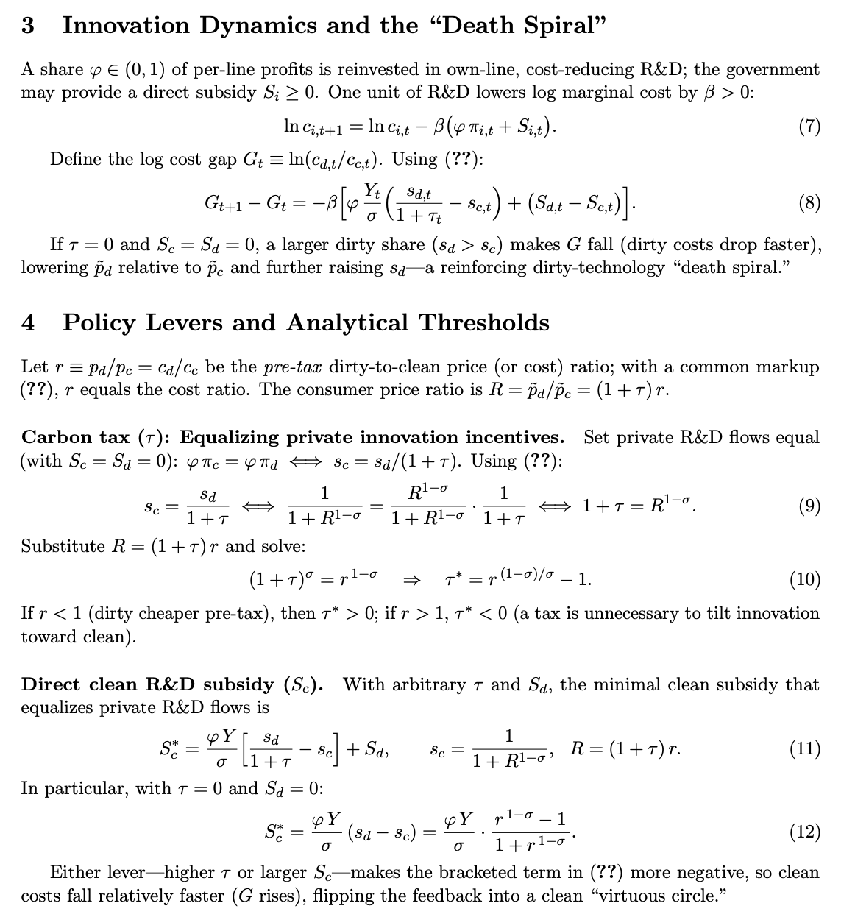
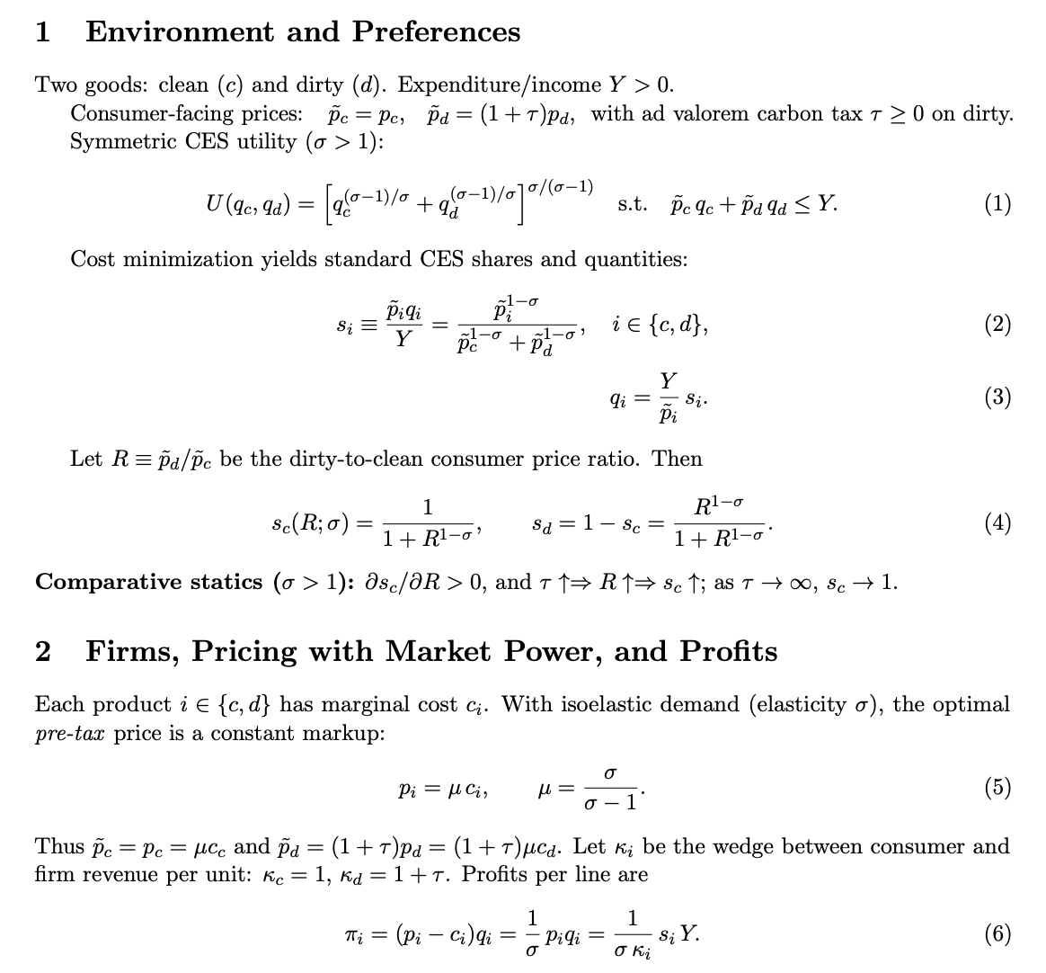

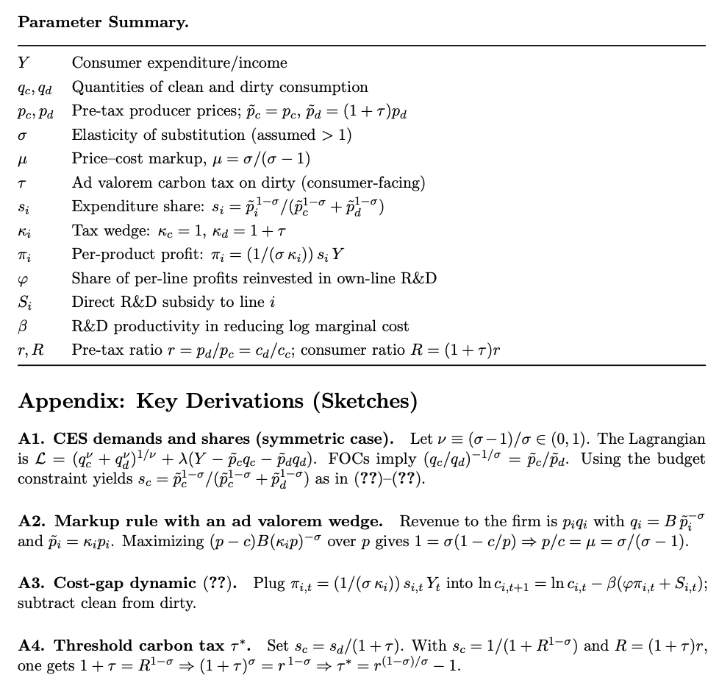

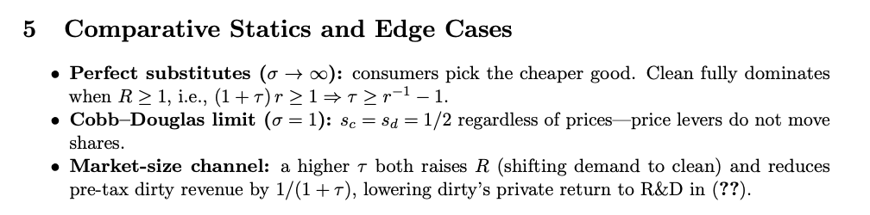

Acemoglu, D., Aghion, P., Bursztyn, L., & Hemous, D. (2012). The environment and directed technical change. American Economic Review, 102(1), 131–166. https://doi.org/10.1257/aer.102.1.131

Find the math in the references
Logical consistency understood as the compliance of three conditions: completeness (you are able to compare any alternatives), transitivity (if you prefer A to B and B to C, you must prefer A to C),and continuity (if you prefer A to B and C is really similar to A, then you prefer C to B)
Economists formally define this as elasticity of substitution
Acemoglu (2024 Nobel Prize Winner), Aghion (2025 Nobel Prize Winner), Bursztyn, and Hemous prove an analogous phenomenon in their paper The Environment and Directed Technical Change (2012), which they label as path dependence. Find also papers on evidence of this mechanism:
The optimal tax pero ton of CO2 is equal to the economic cost of emitting an additional ton of CO2

